**Lab 4P: Decision Structures and Boolean Logic_ 4P_DSBL**

**GADDIS Text Pages 152 - 155**

**Assigned Projects = 4 (85 Pts)**

**Using the IDLE editor (FILE/New Window)……**

**Name: ________Jeff Couch____________**

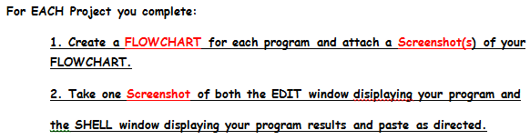

**Project 1: Roman Numerals (25 Pts)**

**Input; number = 8**

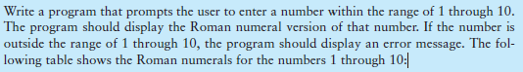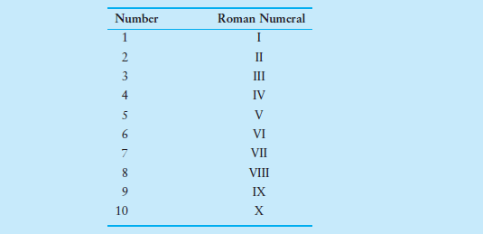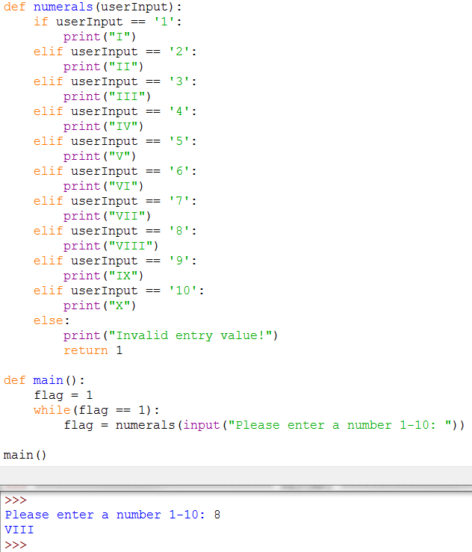

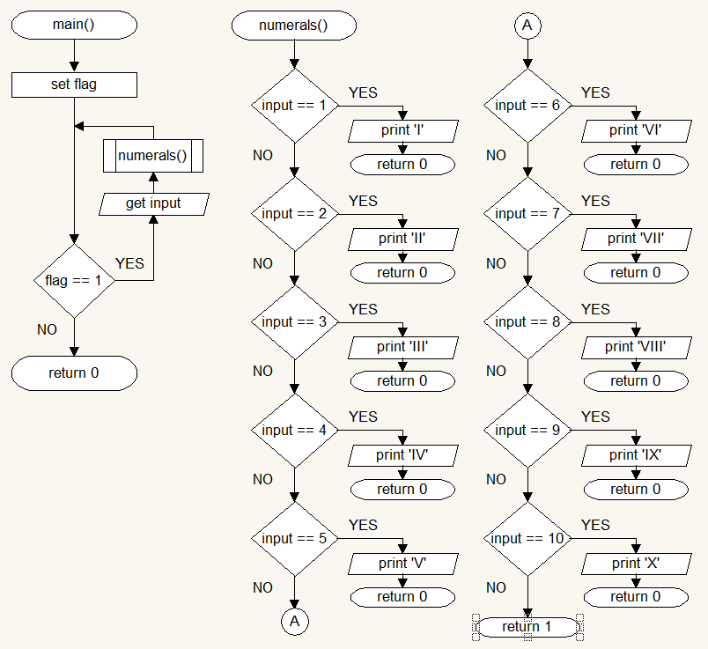

**Project 4: Magic Dates (20 Pts)**

**Input: Month = 5, Day = 18, Year = 13**

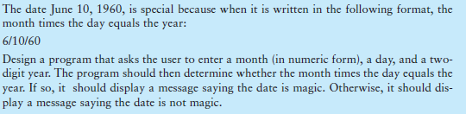

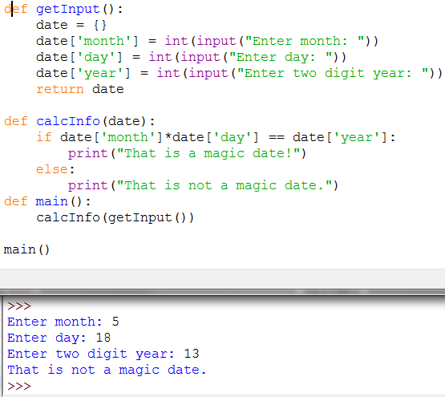

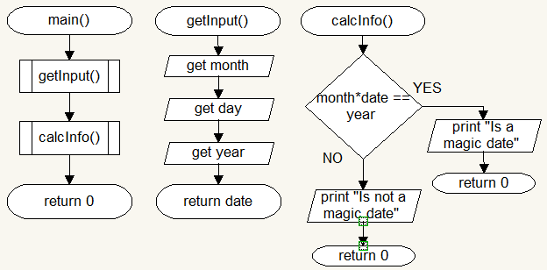

**Project 7: Book Club Points (15 Pts)** 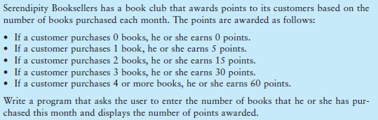

**Input: Books = 5** 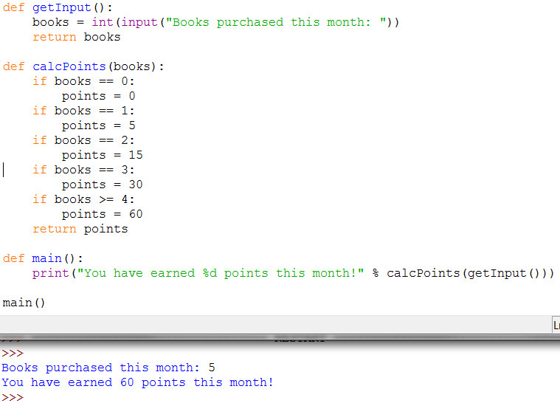

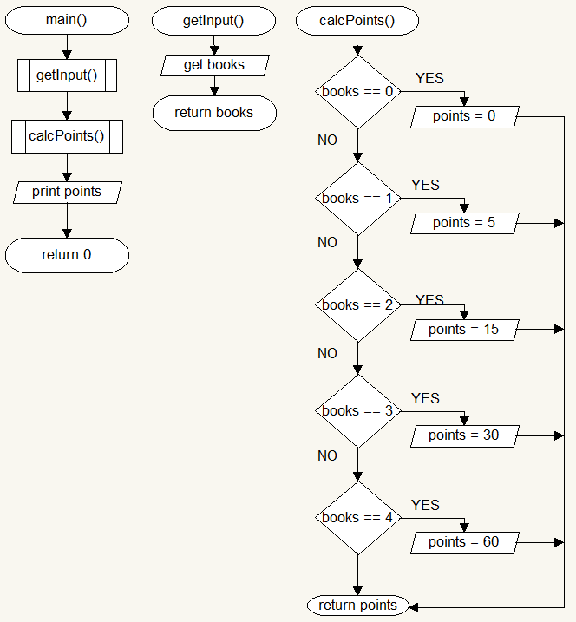

**Project 11: Time Calculator (25 Pts)**

**Input: Time(seconds) = 9500**

